Plate Changing Parbolic Tutorial

In a Perfect world your plates should just bolt on and be ready to go.
But just in case, here is the full process, as learned from Ennoi Mattarelli himself, the designer of this machine

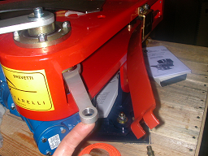
First step is to remove the spring for safety
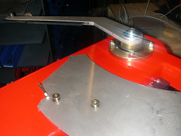

After removing the magazine, this is what you should see. If your machine has been used before this process, you are going to need to dig the target dust out of the Allen holes using a tiny flathead screw driver, or whatever else you can find. It is important that you can see the shiny surface at the bottom of the hole.
Then using the on/off switch turn the machine on, wait for the plate to raise up, then turn the machine off, so that the plate stays in the up position (during this operation it is in your best interest to hold, or have someone else hold, the arm so that it does not fall into the trigger while the plate is up.

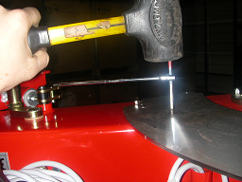
Next, using the tool provided and a hammer, strike the red end with the hammer and apply counter clockwise pressure, exerting the most force during each blow of the hammer. If you do not use the hammer you will strip the screw.

Next remove the old plate. There is a guide rod attached to this plate. You will need an Allen wrench and a blow torch. Heat up the bolt and the guide rod to melt the lock tight (optional but highly recommended).

After removing the guide rod re-attach to the new plate

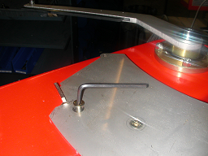
Then bolt on the new plate and lower it.

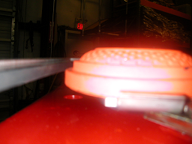
Next you have to check target clearance to assure maximum performance out of your machine. Start with the machine in the cocked position (spring out of machine) and look under the rubber rail to make sure there is clearance between the rubber rail and the target (about 2 or 3 business cards thick).
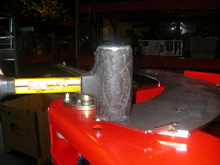
If it is two high, hit it with a no-blow hammer, or use a block of wood and a regular hammer.

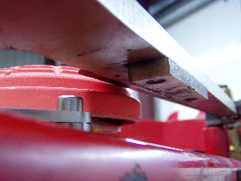 If it is two low and the rubber is climbing on top of the target, then use the main spring to bend it up until you have perfect clearance between the rail surface A and surface B. remember Gentle Strength
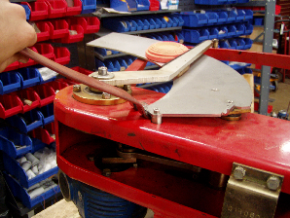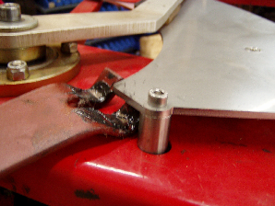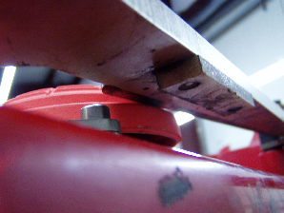
If it is two low and the rubber is climbing on top of the target, then use the main spring to bend it up until you have perfect clearance between the rail surface A and surface B. remember Gentle Strength

Next
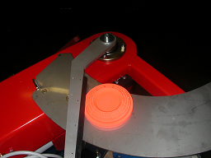
Next move the arm a couple of inches forward.
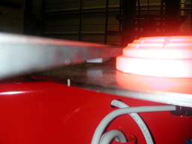
Now you need to check the clearance between surface A and surface B again.
until your clearance is a couple of business cards.
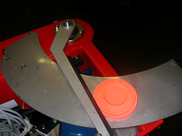
Next move the arm a couple of inches forward.
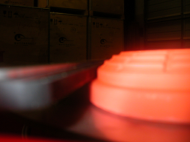
Now check the clearance between surface A and
Surface B. 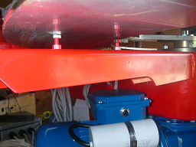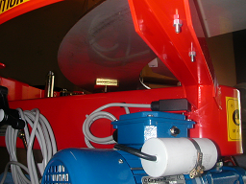
Use a blow torch to melt locktite. Then use these bolts to adjust the
target clearance and make sure that both are making contact.
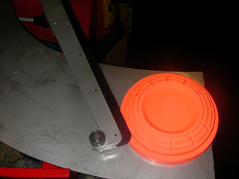
Next move the arm couple of inches and check clearance.
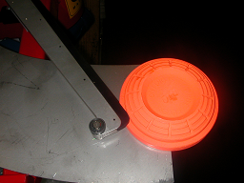
Now move a couple of inches and check clearance

Please remember I have already gone through this process with your plates on a sample machine. In a Perfect world your plates should just bolt on and be ready to go.

