Hard Wiring an Extra Connector to Coin or Smart Card Control System.
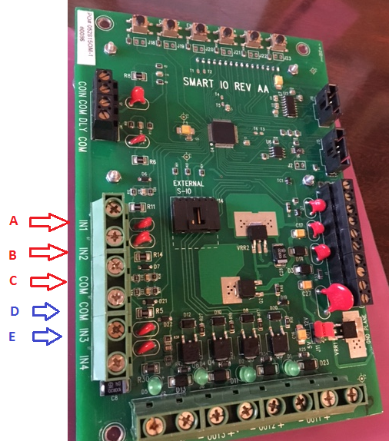
Skeet field
You will need three wires going to a skeet pull cord. The figure above shows terminals A,B,C,D,E.
Terminal A is the signal wire that will release the high house, (typically gun clubs use the black wire for this) and is attached to the black screw on the three prong locking female connector.
Terminal B is the signal wire that will release the low house, (typically gun clubs use the green wire for this) and is attached to the green screw on the three prong locking female connector.
Terminal C is the common wire that is used to complete the circuit for both high and low houses, (typically gun clubs use the white wire for this) and is attached to the silver screw on the three prong locking female connector.
FYI….signal wires are the wires from controller that have a + 12 volt dc charge…. common wires are the wires from controller that have a neg. 12 volt dc charge.
Not all gun clubs use the wire format listed above, just most of them; these color schemes where generated back to the old Winchester days. The following color format is something that is more modern.
Terminal A is the signal wire that will release the high house, (in some cases gun clubs use the black wire for this) and is attached to the black screw on the three prong locking female connector.
Terminal B is the signal wire that will release the low house, (in some cases gun clubs use the white wire for this) and is attached to the silver screw on the three prong locking female connector.
Terminal C is the common wire that is used to complete the circuit for both high and low houses, (some clubs use the green wire for this) and is attached to the green screw on the three prong locking female connector.
If you’re your club does not use one of this two schemes they have gone a bit rogue and it may require looking to see how your pull cords are wired….if you need help, you may want to call us for assistance.
Ata Trap field
You will need two wires that go to your ATA trap pull cord;
Terminal E is the signal wire that will release the trap (typically gun clubs use the black wire for this) and is attached to the black screw on the prong of the locking female connector.
Terminal D is the common wire that is used to complete the circuit, (typically gun clubs use the white wire for this) and is attached to the silver screw on the prong of your locking female connector.

