COIN BOX TWO FEATURES
Rev 9-1-10

1. Coin count down to zero
After coins are inserted, targets may be released, the counter counts
down to zero, at which time no more targets can be released until more
coins are inserted.
2 Reload Trap LED light indicator.
This feature counts the birds in the magazine and lets staff know how many
targets are still in magazine as well as turning on a light when you have fewer
than 100 targets left in the magazine.
3. Coin by-pass count up option
This option allows management to by pass the coin operations mode for
tournament and teaching sessions.
4. Delay function **Self Pull Switch
This feature allows you to switch it to a delay 2.5 second delay release for shooters wishing to shoot alone.
5. INTERNATIONAL DELAY FOR SKEET.
Zero to 3 seconds random delay for those wishing to shoot international skeet.
6. Life Time target count** This lifetime count display the total number of targets
shot through the coin box. An excellent inventory control feature.
7. First Coin special value option; otherwise known as Z count.
Although seldom used, this feature allows one to have the very first coin register a different value than all subsequent coins.
8. ATA voice release compatible
This system is compatible to use with all voice release systems.
9. Double Count Feature Option
Use for ATA Trap Doubles. The coin box counts two each time the ATA
trap pull cord or voice release is engaged.
10. Auto Zero option…controls can be set to zero out counter if field remains
unused so non paying shooters can’t shooter unused targets left by previous
shooters.
Quick Install Hint.
If you are like me, you hate to read instructions. For those who just want to get it installed and not know what every terminal is, just stick with the color coding and ignore the rest.
First. You’re going to need a 12 volt DC power supply because the coin box operates on 12 volt. Connect power to bottom two terminals on the right of the mother board located at the front door. Radio Shack has the 12 converters 1000 MA.
Skeet only….follow the directions that are color in Green.
Trap only….. follow the directions that are color in Burgundy.
Trap and Skeet.. follow the directions that are color in Green and Burgundy.

Located at the top left of the mother board on the door of the coin box. This page addresses where you hook up pull cord wires or voice release.
Left Top Terminals on Mother Board
Coin Coin slot micro switch
Com Common for coin Slot micro switch
Pick 1 High skeet pull cord wire (signal wire)
Com Common wire for skeet pull cord
Pick 2 Low skeet pull cord wire (signal wire)
Com
Pick 3 ATA Pull cord wire (signal wire) Or voice release signal wires
Com Common wire for ATA trap pull cord Or voice release common wires
Opt 1 Factory set used to up count on target magazine counter
Com Magazine counter common
Left Bottom Row Terminals on Mother Board
Opt 2 Factory set used to down count on target magazine counter
Com
Delay 2.5 second fixed delay (target will release 2.5 seconds after button is enable)
Com Jump the terminal with the delay terminal to enable this feature.
Var Delay International skeet variable delay (enable switch inside box when ordered)
Common Jump the terminal with the Var delay to enable international delay feature.
FYI ( all common terminals are interconnected and shared)
Right Hand Row of Terminals on right hand side of Mother Board
+ Factory Set ( pos 12 volt signal to output relay board) High skeet house
1 Factory Set (Negative 12V for above terminal)
+ Factory Set ( pos 12 volt signal to output relay board) Low skeet house
2 Factory Set (Negative 12V for above terminal)
+ Factory Set (pos 12 volt signal to output relay board) ATA trap
3 Factory Set (Negative 12V for above terminal)
+ NA
4 NA
+ NA
5 NA
+ NA
6 NA
+ NA
7 NA
+ Positive 12 volt terminal for magazine reload indicating light
8 Factory Set (Negative 12V for above terminal)
Bottom Right Hand- 12 DC power Terminals
Gnd 12V DC negative power supply
12v 12V DC positive power supply

See Figure Below………..

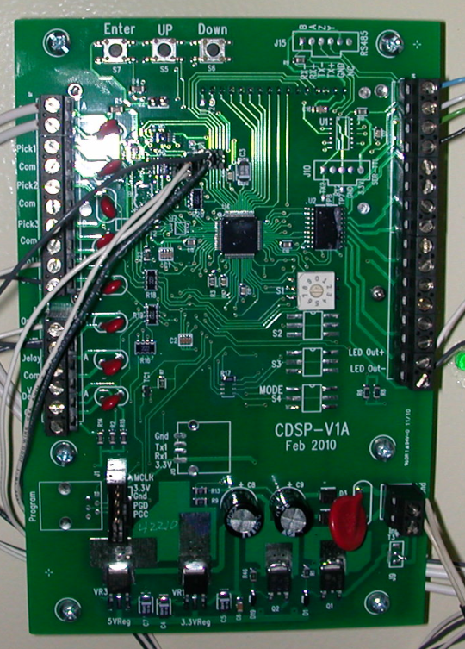

RELAY BOARD
Located inside the coin box behind the coin operator.
This information addresses where you hook up your skeet or trap machines.
These relays are what actually make the contact with the trap allowing it to throw a target.

Top Row of Terminals – From right to left

L+ High House Skeet Trap (connect skeet machine signal wire to this terminal)
L- High House Skeet Trap (connect COMMON wire to this terminal)
R+ Low House Skeet Trap (connect skeet machine signal wire to this terminal)
L- Low House Skeet Trap (connect COMMON wire to this terminal)
3+ ATA Trap Machine (connect ONE OF THE WIRES from the trap to this terminal)
3- ATA Trap Machine (connect THE OTHER WIRE from the trap to this terminal)
4+ NA
4- NA

Bottom Row of Terminals- from right to left
These terminal are factory set and accept the 12 volt signal from the mother enabling the relays…They are factory set.

S1+ This accepts 12 volt positive signals from 1+ on mother board (right side row of terminals).
S1- This accepts 12 volt positive signals from 1 on mother board (right side row of terminals).
S2+ This accepts 12 volt positive signals from 1+ on mother board (right side row of terminals.
S2- This accepts 12 volt positive signals from 1 on mother board (right side row of terminals).
S3+ This accepts 12 volt positive signals from 1+ on mother board (right side row of terminals.
S3- This accepts 12 volt positive signals from 1 on mother board (right side row of terminals).
S4+ NA
S4- NA
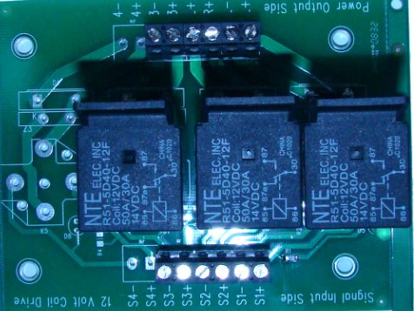

DISPLAY

The display will show multiple values like;
BRILEY C27 Z0
SHOTS 100
BIRDS 75
TOTAL 35

C 27 means that the token value is set at 27 targets per token.

Z0- For those who want the very first coin to be worth a different value, the board can be programmed to give extra shots. A reading of Z2 would mean that the first coin would be worth 29 targets and all the rest would be worth 27 targets. This function is not often used, feel free to disregard it if it does not interest you.

SHOTS ….this is the amount of credit you still have on the coin box before you need to add more coins.

TOTAL. This will register the total count of all the targets that are shot through the system in its life time…. If it reads 2,000,000 it would mean you have shot 2 million targets through this coin box.. This is a great feature to insure that all the coins are being collected and returned to the office for resale.

Programming and function setting

Rotary Switch Settings 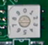

0 Regular coin operation setting. If there are credits left they will remain until the counter is manually zeroed
1 Coin operation with Auto Zero. If no shots have been fired in 15 min the counter will zero out by it self.
2 Coin operation with Auto Zero. If no shots have been fired in 20 min the counter will zero out by it self.
3 Coin by pass; no coin is necessary to operated the system. Used in tournaments
4 NA
5 NA
6 Relay pulse length setting. This setting allows you to set the length of pulse you want the contacts to stay closed. Manually we do this all the time when we notice some old machines requires one to press and hold button down longer so the machine will release. This setting allows one to do exactly the same thing with this function. Set the rotary switch to #6 and read the front display, you will see that you can set pulse from .15 seconds to .9 seconds long (factory default is .33). To change, press the up or down arrow on the top of the back of the mother board. Take it to the pulse length and press enter. Don’t forget to return rotary switch dial to normal operating setting.

7 This setting is use to programmed the coin value. Factory default is 27. To Program a different coin value set this rotary switch on 7 and follow the directions on the panel of the coin box. Note figure below. These buttons are located on top of mother board. To increase the value of 27 to 29 you would press the “UP” twice and hit enter. The coin value would be 29 which would be displayed on your counter. Once you do this return rotary switch “0” for regular coin operation.

8 Double Count for Trap Doubles….move rotary switch to position 8 and follow directions on screen using the 3 buttons shown below pressing the “UP” or “Down” button until the front panel value read “9”. Press the enter button and return rotary switch back to the number 0 (coin operation setting) you are now set to shoot double traps which mean it will count in twos not ones. IT IS IMPORTANT TO NOTE: when you are done shooting doubles trap this value should be returned to “ZERO”. Any value other than 0 on this setting will reflect as a Z value. That means the first coin value will increase. For instance lets say you put this value at 5. The front panel will read a Z5. Remember this means the first coin inserted, would not be worth 27 targets it will be worth 32 targets (27+5=32). Be sure to return this value to zero.

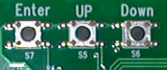

Magazine Count Feature
When you load the trap machine the coin box must be informed of this so he can accurately know when to warn you to reload the magazine. On the right side of the coin box you will see a switch. Every time you push this momentary switch upwards it will add 100 targets to the “Birds” count. So if you have magazines in the skeet house that hold 500 targets each, you would operate the momentary switch up enough times until it registered 1000 (count for both houses) on the “Birds” count. If you go past, you may need to move switch downward, it will degrease in 25 target increments.
.
Clearing the counter to Zero

There is a momentary switch on the bottom of the box. Move it to the right and the counter will clear to Zero.

There you have it! Now go out and be profitable and reproduce!


Phone 713 932 6995 1230 Lumpkin, Houston, Texas 77043

