INSTRUCTIONS FOR COIN BOX
Software release update 9/15/07 “Cov1”
FEATURES;
1. Coin count down to zero
After coins are inserted, targets may be released, the counter counts down
to zero at which time no more targets can be released until more coins are inserted.
2. Coin by-pass count up option
This option allows management to by pass the coins for tournament and teaching sessions, counter will count up total number of targets shot that session.
3. Delay switch **
This feature allows you to switch it to a delay 2.5 second delay release for shooters wishing to shoot alone.
4. Life Time target count** This lifetime count appears everything time coin box is powered up.
With the COV1 software release it is now possible to keep a count on total targets shot during the life time of the coin box board; max count 99 million.
5. First Coin special value option
Although seldom used, this feature allows one to have the very first coin register a different value than all subsequent coins.
6. Four trap option
Coin box can control up to four different traps.
7. ATA voice release compatible
This system is compatible to use with all voice release systems.

PROGRAMMING ROTARY SWITCHES
Switch #1 (counting from top to bottom)
Figure 1 (middle, right side) shows 4 programming rotary switches. Switch #1 is factory set at Zero. This switch pertains to the First Coin Special Value Option. For example, if you wanted the very first coin to be worth 2 targets more than all other subsequent coins, you would set the rotary switch on 2. If you wanted the value to be worth four targets more you would set it on 4. This function is never used in skeet or trap and only very seldom used in sporting.
Switch #2 and #3 (counting from top to bottom)
Switch number 2 and 3 are for the purpose of programming the value of target per token.
For instance, if you want each token to be worth 27 targets you would set switch #2 to the number 2 and switch #3 would be set on 7. Example two; let say you are celebrating your birthday and you had a special that day where everybody could shoot for half price and each token would be worth 54 targets. The setting on switch #2 would be on the number 5 and the setting on switch #3 would be set on the number 4………..Switch #2 represents the first digit of your two digit number and switch #3 represents the second digit of your two digit number.
Switch 4 (bottom switch); Programming different functions.
PROGRAM FORMAT
0 Normal Coin Operation
3 Displays the programmed valued of each coin
6 Count up function with coin by pass. Use this setting for Tournaments.
Zero Counter
There is a switch under the box, push it over to the on position and the counter zero’s, then return it to the off position.
DELAY FUNCTION.
Figure 1 shows two cables that are pertinent to the delay function. Inside the coin box you will find a switch that enables the delay function. Turn it to the on position when you want this function enabled.

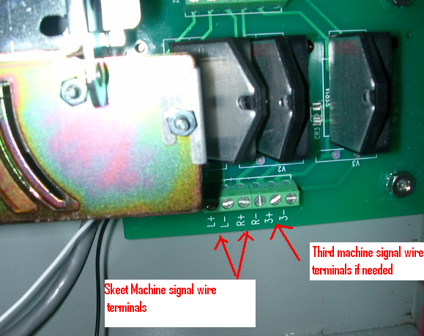
FIG A “shows AC relay board”
Wiring your skeet machines to your relay board which is located on the back of the of the coin box.
All traps have a release cord. This cord has two wires (a common wire and a positive wire, known as the signal wire), when these two wires make contact the machine releases the target. Incidentally, these wires are typically hooked up to the center post terminal where you plug in your pull cord.

Connect skeet machines;
High house
Connect the high house POSITIVE wire to “L+” terminal
Connect the high house COMMON wire to “L-” terminal
Low house
Connect the low house POSITIVE wire to “R+” terminal
Connect the low house COMMON wire to “R-” terminal
Connect ATA trap machines;
Connect the ATA trap POSITIVE wire to “3+” terminal
Connect the ATA trap COMMON wire to “3-” terminal

NOTE!!!!! POLARITY IS IMPORTANT. If you reverse polarity strange things happen! So hook up the positive wire to the positive terminal and the common to the Negative terminal…….

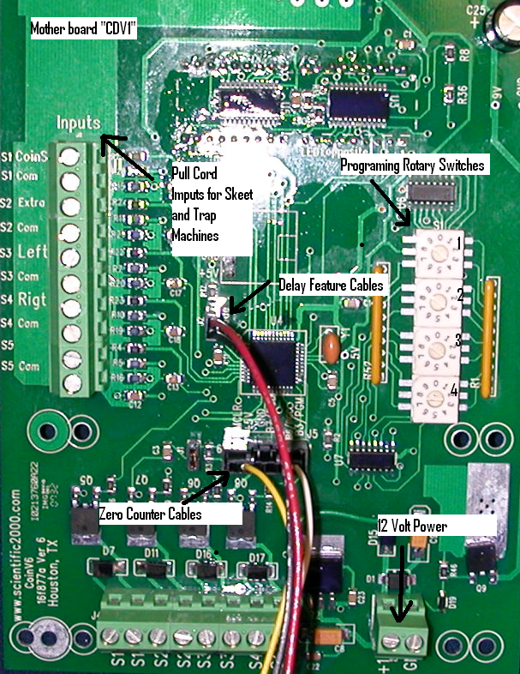
FIG 1
Skeet Installation, pull cord wiring;
Connect your pull cord signal wires to the pull cord terminals as shown on the figure above (top left side). Connect your (pull cord) high house single wire to the terminal marked “LEFT”. Now connect your (pull cord) low house single wire to the terminal marked “Rigt” and finally connect your common wire from your pull cord to the terminal marked “Com” on the terminal that is in-between “Left” and “Rigt” terminals.
ATA Trap Installation, pull cord wiring;
Connect your pull cord signal wires to the pull cord terminals as shown on the figure above (top left side). Your trap pull cord wire will have two wires. One will be the signal wire (connect this wire to the terminal marked “extra”) and the other will be the common wire which connects to the terminal right below it which reads “Com”.
POWER for coin box;
Your coin box operates on 12 volt power. You must provide a 12 volt power source to it. We recommend that
you purchase a 12 volt converter at Radio Shack and use this as a power source. Fig 1 shows (bottom right) the
terminals were you connect 12 volt wires to.

Voice release hook up instructions:

Your voice release system will have a relay box in the trap house. It currently has a two wire cord that connects to the release wires on the trap. Disconnect these two wires. The two wires that come from the trap machine connect as follows on the relay board (fig A);

Connect the ATA trap POSITIVE wire to “3+” terminal
Connect the ATA trap COMMON wire to “3-” terminal

The two wires that come from the voice release relay box connect to the mother board (Fig. 1) as follow;

Connect your voice release wires to the pull cord terminals as shown on the figure 1 (top left side). Your voice release pull cord wire will have two wires. One will be the signal wire [pos] (connect this wire to the terminal marked “extra”) and the other will be the common wire which connects to the terminal right below it which reads “Com”.

Lifetime Target Count; How to read the count.
When the coin box powers up for the first time the counter display will light up for 3 seconds and displays the first four digits of a 8 digit number. It will blink off and then display for 3 seconds another 4 digit number, this represent the last four digits of an eight digit number. After the second four digit number is displayed for 3 seconds the readout will display coin count targets left, if any. Example, when powering up if the first readout showed 0002 and the second readout showed 1256 your target count would be 00021256, twenty one thousand two hundred and fifty-six targets.

