5 STAND CONTROL BOX Rev 7/7/2009
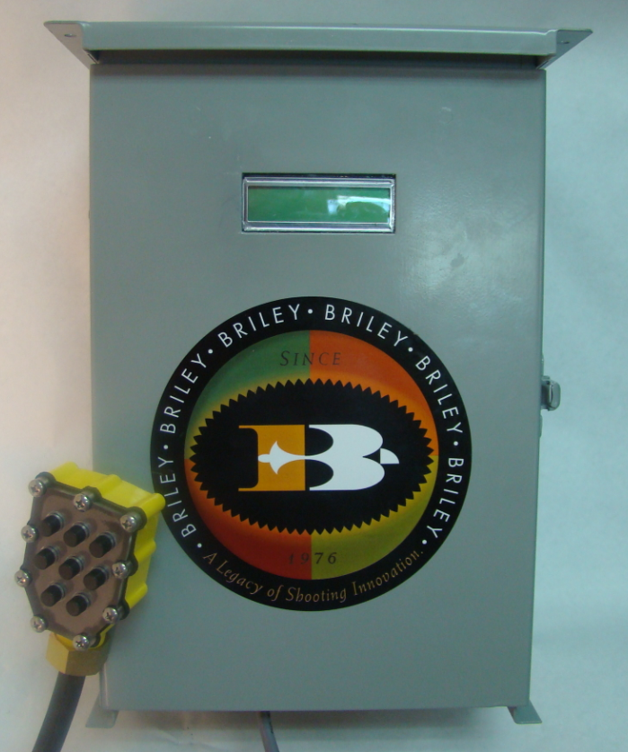
Installation instruction;
Mounting;
Mount the box where it is most convenient to your operation. Please be sure to mount it square so the coins will work correctly in the receiver.
Power;
Your coin box operates on 12 volt power. You must provide a 12 volt power source to it. We recommend that you purchase a 12 volt converter at Radio Shack and use this as a power source. Fig below shows details;

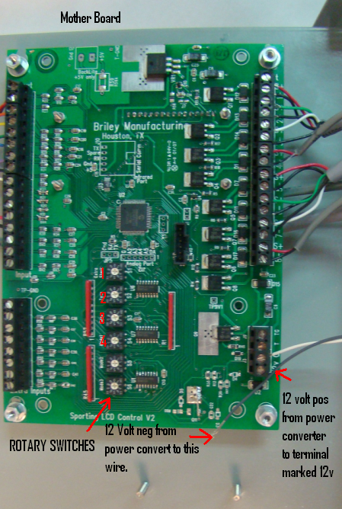
Connecting traps to coin box;
The figure below give details on how to wire traps to coin box relays;

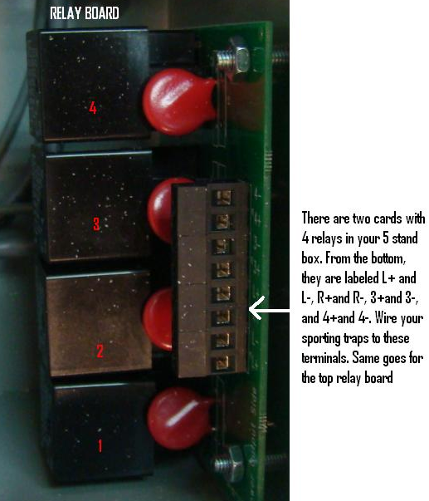

FYI. The very bottom relay in the box will respond to the #1 one button on the pull cord and ascend as they go up; so the very top relay in the box will be number #8.
Clearing the counter;
There is a toggle switch on the bottom of the box; toggle it to clear counter.
PROGRAMMING ROTARY SWITCHES
Switch #1 (counting from top to bottom) see figure marked Mother Board.
This switch pertains to a First Coin Special Value Option. For example, if you wanted the very first coin to be worth 8 targets more than all other subsequent coins, you would set the rotary switch on 8. If you wanted the value to be worth four targets more you would set it on 4. This function is for making allowance for “look birds”.
Switch #2 and #3 (counting from top to bottom)
Switch number 2 and 3 are for the purpose of programming the value of target per token.
For instance, if you want each token to be worth 27 targets you would set switch #2 to the number 2 and switch #3 would be set on 7.
Switch 4 (bottom switch); Programming different functions.
PROGRAM FORMAT
0 Normal Coin Operation 3 Displays the programmed valued of each coin
6 Count up function with coin by pass. Use this setting for Tournaments.

