5 STAND COIN BOX INSTRUCTIONS rev 5-07
Mechanical relays

1.Start by mounting the coin box somewhere convenient.
2.Next your going to need a 12 volt converter (1000 milliamps) to power up the coin box.
You can buy it a Radio Shack for less than 20 dollars. There are two loose wires
attached to the switch for you to connect the converter to.
3. Now we want to hook your sporting traps to the relays boards inside the box. See figure below. This is an example of a board that contains four relays. Each terminal will control one trap. Connect the wires to your trap on the terminals. Notice they are marked + and –; be sure to connect your common wire to the negative terminal. Connect all traps to relay boards terminals.

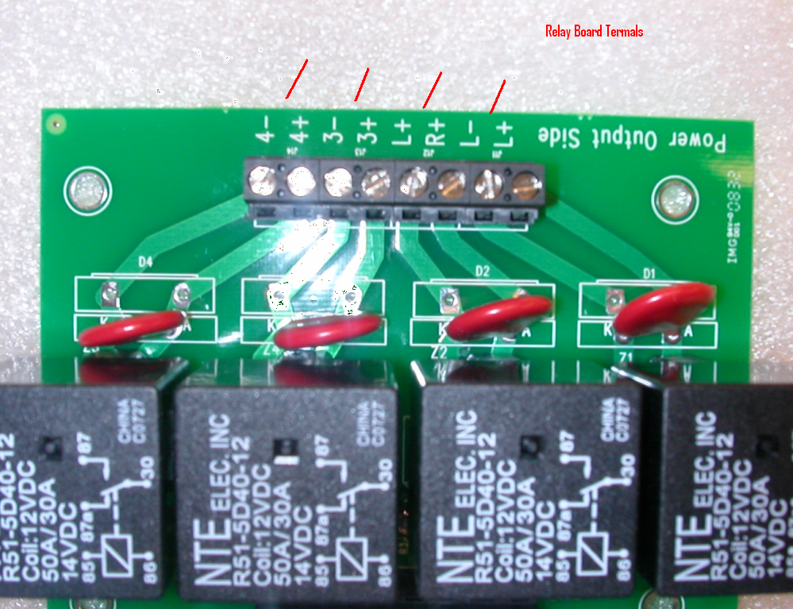

SETTINGS
Switch number 1
The picture below is the mother board. See the white rotary switches?
The two bottoms ones are not essential. The top four are for programming purposes. The top switch (1), applies to the value of the first coin only.
For instance, if you want to set the coin box so when you put the very first coin in, it gives you 8 look targets (extra targets to look at) you would set the rotary switch #1 on 8. So this means the very first coin would be worth 8 targets more than following coins. If you do not want look targets; set this switch on zero! Please note; the first coin value feature only applies when the counter reads zero. If there are extra targets on the counter this feature does not engage.
Switch number 2 and 3
This is the way we set the value of the coins. If you want the value of the coin to be 27 targets you would set switch #2 on the number two and switch #3 on the number seven.
Switch number 4
Operation mode switch. For regular coin operation set the switch on ZERO. For coin by-pass set it on the number SIX.

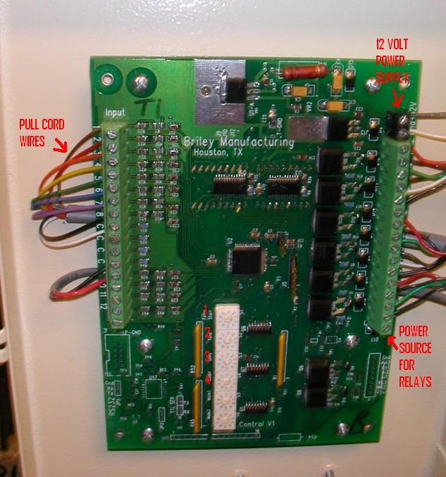

To zero out counter. The switch underneath will power the operator down and zero out the counter…That’s it!

